GCIS123 – Assignment 1 – Joel, Clevin, Sai
Problem solving & Design explanation

- Problem decomposition
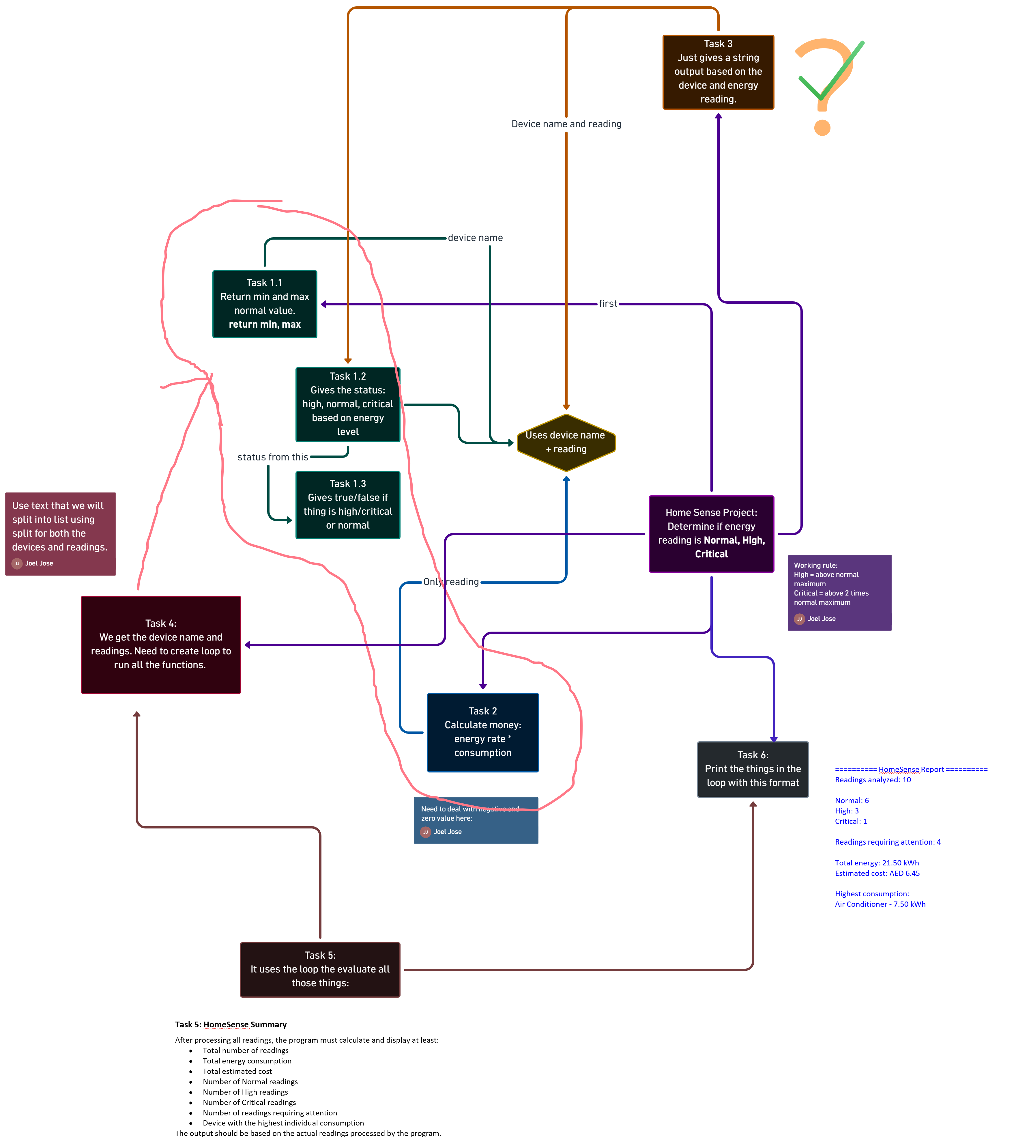

The problem of home-sense was solved using 11 functions. Some of the functions used smaller functions inside them. We broke down the problem based on complexity.
We first created a mind map of the different functions to be created to solve the problem. We then connected them to each other, trying to indicate how the flow of data occurs.
If a function required a task that could be repeated elsewhere, instead of copying the code; we created a function. For example, the “check_zero_or_negative()” function was used in both the “getting_status()” and “getting_energy_cost()” functions. This is because both functions required us to check if the reading was negative or zero. Other examples include the “count_readings()” function used in the “mul_analysis()” function to count the number of normal, high and critical readings.

- Decision Making
When given a reading, we needed to classify it as normal, high or critical. In order to find the limit for high and critical, we searched the web. According to industry specifications, a device has critical energy levels if it is past 200% of the normal energy limit. So, we implemented this into our program by stating:
If the energy level is twice as high as the highest limit for a normal reading; it is critical.
If it is higher than the limit but less than twice: it is High.

- Boundary cases
We designed the code such that if the energy reading happens to be at the highest limit for a normal reading, that reading is considered high. If it is exactly twice the highest limit for a normal reading, that reading is considered critical. We checked one of these conditions in our test files using pytest.

- Different Devices
Different devices needed different energy limits because they all utilize different amounts of energy. An LED bulb may use only 5-10 watts of power whereas an Air conditioner could use 1000 to 4000 watts of power. As such, if we used fixed limits to find out if the reading was normal, high or critical: we could get multiple alerts despite the device having a normal amount of energy and working adequately.

- Multiple Readings
When we factored in multiple readings, we had to consider the total amount of readings, the total amount of energy used and total cost of running all the devices. So instead of just finding the cost and energy of a single device, we needed to find that for multiple devices and then add them up. We also considered the device with the highest energy, the total number of normal, high and critical readings etc.

- Testing
The most crucial tests we did was the ones regarding the getting_status() function. This function acts as the core of our project. If the logic was incorrect here, then our entire code would have to be redone. So, we used pytest to make sure the logic was sound; ensuring it gave the right readings when they were high and when they were at a boundary value.

